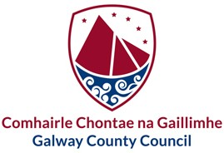

Designated Public Officials in Galway County Council

|  |  |
| --- | --- |
| **Executive Team** | |
| Liam Conneally | Chief Executive |
| Katie O’Connor | Head of Finance, Motor Taxation, ICT and Digital Transformation |
| Eileen Ruane | Director of Services – Corporate Services, Environment and City & County Libraries |
| Liam Hanrahan | Director of Services - Planning & Economic Development |
| Michael Owens | Director of Services - Housing |
| Uinsinn Finn | Director of Services – Physical Development, Fire & Emergency Services and Climate Change |
| Jacqueline Carroll | Director of Services – Rural & Community Development and Integration & Environment |